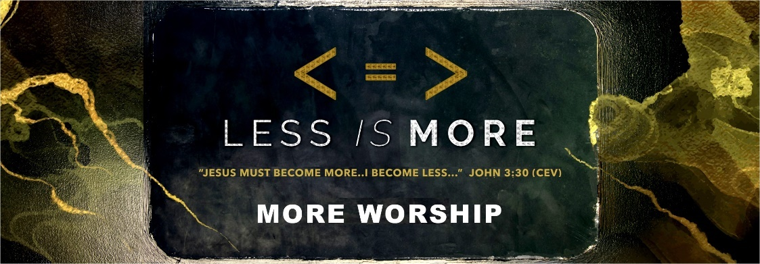

The Crossings Church and Each Member Exists to Worship God

- worship is not…

- ________________is not worship.

And stop making that music for Me—it’s just noise. Amos 5:3a (Voice)

- ________________is not worship,

LORD God All-Powerful, how much longer will the prayers of your people make you angry? Psalm 80:4 (CEV)

- ________________of hands is not worship

There's nothing wrong with God; the wrong is in you. Your wrongheaded lives caused the split between you and God. Your sins got between you so that he doesn't hear. ³Your hands are drenched in blood, your fingers dripping with guilt… Isaiah 59:2, 3 (MP)

- ________________is not worship

Who among you would shut the doors that would keep Me from smelling your sacrifice and you from wasting time kindling the fire on My altar? I, the Eternal, Commander of heavenly armies, don’t delight in you. I will not accept any offering you present. Malachi 1:10 (Voice)

- ________________is not worship.

On this next matter, I wish I could applaud you; but I can’t because your gatherings have become counterproductive, making things worse for the community rather than better…. ²⁰ when you come together because it is not the Lord’s Supper you are eating at all. I Corinthians 11:17, 20 (Voice)

- ________________________________is not worship

'These people honor Me with their lips, but their hearts are far from Me. ⁹ Their worship is a farce, for they teach man-made ideas as commands from God.'" Matthew 15:8, 9 (NLT)

NOTE: One can perform “acts of worship” and ________ __________.

- worship is an ___________________of the heart / mind.
So let us be thankful, because we·have [are receiving] a kingdom that cannot be shaken. [As a result; or In this way] We should worship God in a way that pleases him with ·respect [reverence; devotion] and ·fear [awe], ²⁹ because our God is·like a fire that burns things up [^{L} a consuming / devouring fire. Hebrews 12:28 (EXB)

NOUN: The feeling or expression of reverence and adoration for a deity.

VERB: Show reverence and adoration for (particularly a deity)

Hebrew: Hishahawah – “a bowing down”, submission, deep respect.

Greek: Proskuneo – “to kiss the hand”, “bow down”

- At the heart is a heart that says “God is more…I am less!

"'Love the Lord your God with all your heart and with all your soul and with all your mind...” Matthew 22:37 (NIV)

- worship is an attitude that is displayed in ____________.

- When I possess the attitude of worship in my heart/mind….

  - My Songs become worship.

And now, because of Jesus, the non-Jewish people of the world can glorify God for his kindness to them, fulfilling the prophecy of Scripture: Because of this I will proclaim you among the nations and they will hear me sing praises to your name.[ Romans 15:9 (TPT)

  - My Prayers become worship

Pray then like this—‘Our Heavenly Father, may your name be honored; May your kingdom come, and your will be done on earth as it is in heaven.
Matthew 6:10 (Phillips)

  - My Giving becomes worship

“I don't want your sacrifices – I want your love! I don't want your offerings – I want you to know Me!” Hosea 6:6 (LB)

  - Raising my Hands becomes worship.

We raise our heart and hands toward God… Lamentations 3:14 (NASV)

  - My _________ __________becomes worship..
So brothers and sisters, since God has shown us great mercy, I ·beg [urge; appeal to] you to offer your ·lives [selves; ^{L} bodies] as a living sacrifice to him. Your offering must be ·only for God [holy] and pleasing to him, which is the ·spiritual [or authentic;true] way for you to worship. Romans 12:1 (EXB)

- ….and the world will take notice.

When I am lifted up from the earth, then all of humanity will be drawn to Me. John 12:32 (Voice)

